UNIVERSITY OF MINES AND TECHNOLOGY (UMaT)
TARKWA, GHANA



Department of Cybersecurity and Information Systems
BSc Cybersecurity | Level 300
LABORATORY REPORT

LAB PROJECT 1
False Warning About Computer Virus

Lecturer: Dr. Eric Affum

Submitted by: ENOCH NANA TABI ODURO
Student ID: FCM.41.018.197.23

2ND SEMESTER
Submission Date: July 8th, 2026
2025/26

Task 1: Definitions

1.1 Computer Virus
A computer virus is a form of malicious software that attaches itself to legitimate host files or program and depends on that host to run. It cannot spread on its own. A virus needs a human action to activate, whether that is opening an infected file, or booting from an infected disk. Once it executes, it inserts copies of its own code into other files or programs on the same machine. From there it can spread further when an infected file is shared via a USB drive, an email attachment, or a downloaded program. The effects range from pop-ups and slowdowns, corrupting or deleting files, disabling security software, or opening a backdoor.

1.2 Computer Worm
A worm is a fully self-contained malicious program that, unlike a virus, does not need to attach to a host file and does not require a person to run it. Once a worm gets onto one machine it actively scans the network for vulnerable systems and copies itself across, spreading from computer to computer with no user interaction required. Because of this self-replicating, network-aware behaviour, worms can propagate extremely fast across an organisation or the internet. They often cause damage simply through the volume of traffic and system resources they consume, on top of any payload they carry such as installing a backdoor or dropping ransomware.

1.3 Spyware
Spyware is software installed on a device, usually without the user's informed consent, that secretly monitors activity and collects information such as browsing habits, keystrokes, login credentials, or personal files, then sends that data to a third party. Unlike viruses and worms, spyware's primary goal is not to damage or replicate but to covertly gather information for purposes like targeted advertising, identity theft, or corporate espionage. Common sub-types include keyloggers that record every keystroke, adware that tracks browsing to serve targeted ads, and trojans bundled with seemingly legitimate free software.

1.4 Quick Comparison

Feature | Virus | Worm | Spyware
Needs a host file | Yes | No | No
Needs user action to spread | Yes | No (self-propagating) | Usually (via install)
Primary goal | Damage / disrupt | Rapid spread / exhaustion | Covert data collection
Typical delivery | Infected files | Network vulnerabilities | Bundled installers

Task 2: Antivirus Software
Note: The links provided by the lecturer (free-av.com and avast-2007.com) are outdated and no longer reliable. Both domains have either been discontinued or taken over, making them unsuitable for downloading security software in 2026. The official current download sources were used instead.

2.1 Software Selected
Antivirus product installed: Avast Free Antivirus
Date of installation: 7th July, 2026

2.2 Installation Steps
- 1. Navigated directly to the official vendor website by typing the URL manually, avoiding search ad results. (avast.com/free-antivirus-download)
2. Selected the Free tier and downloaded the installer to the Downloads folder.
3. Right-clicked the installer and confirmed the publisher identity in the Windows User Account Control prompt before allowing it to run.
4. Accepted the licence agreement and declined any bundled toolbars or browser extensions during setup.
5. Completed a standard installation and restarted the machine when prompted.
6. On first launch, allowed the program to download the latest virus definitions before proceeding.
7. Confirmed that real-time protection was active on the dashboard.

2.3 Installation Evidence
Screenshot 1: Successful installation confirmation screen.
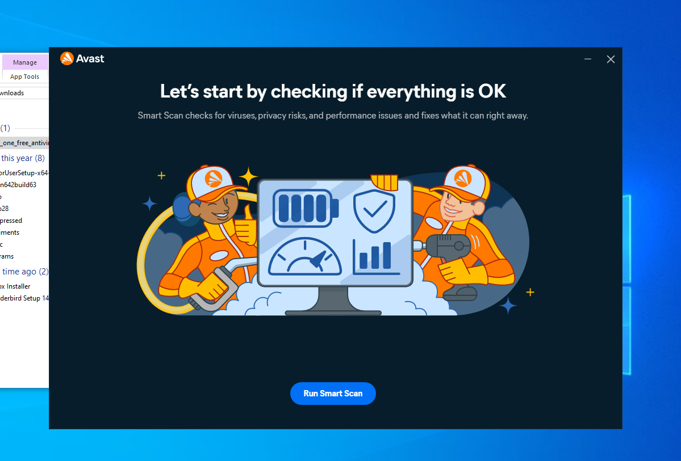
Screenshot 2: Antivirus dashboard showing real-time protection features
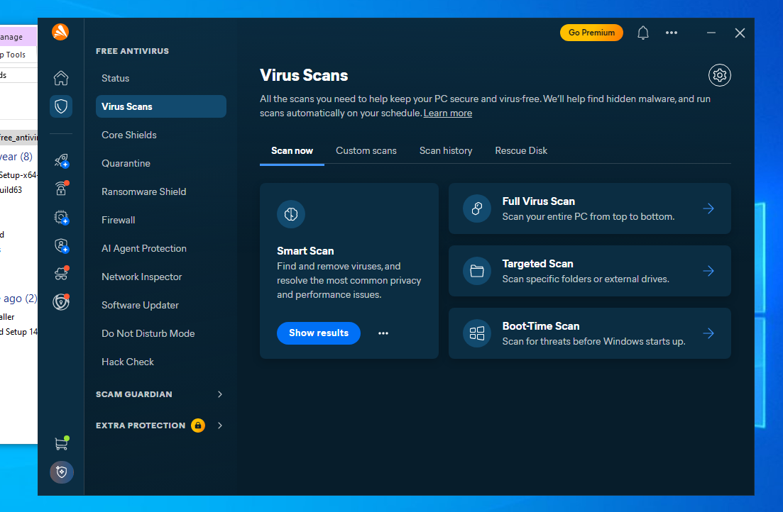

Task 3: Anti-Spyware Software
Note: PC Tools Spyware Doctor was discontinued after its acquisition by Symantec and is no longer available. Spybot Search and Destroy (from Safer Networking Ltd.) remains actively maintained and was used for this task. Malwarebytes Free serves a comparable role and is a well-regarded alternative.

3.1 Software Selected
Anti-spyware product installed: Spybot Search and Destroy 2.9.85.5
Date of installation:7th July, 2026

3.2 Installation Steps
1. Downloaded the installer directly from the official source (safer-networking.org or malwarebytes.com).
2. Ran the installer, accepted the licence terms, and selected the Free edition when prompted.
3. Declined any additional bundled tools or browser add-ons during setup.
4. Launched the program and allowed it to download the latest spyware definitions before scanning.
5. Confirmed the on-demand scanner was ready for use.

3.3 Installation Evidence
Screenshot 3: Successful installation confirmation screen.

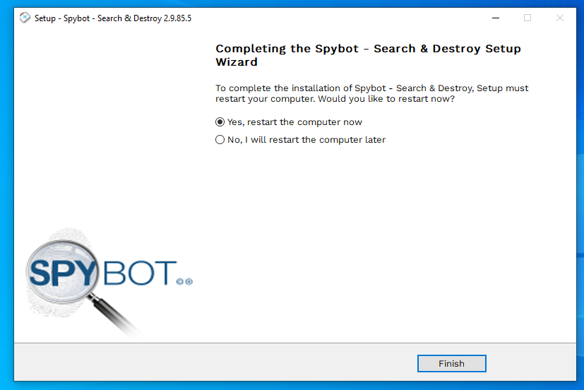
Screenshot 4: Anti-spyware dashboard showing definitions/database up to date.

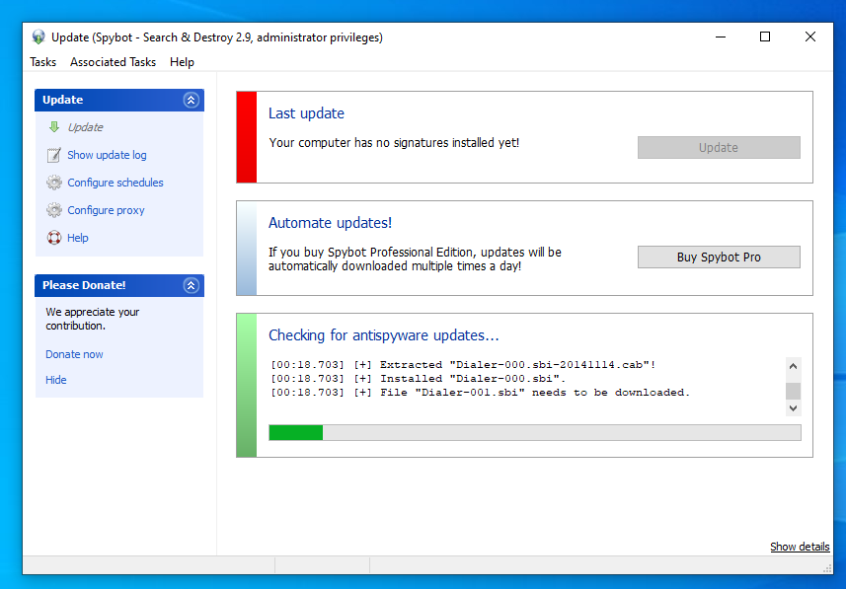

Task 4: Virus and Hoax Email Exercises

4.1 How to Tell a Hoax from a Real Threat
Before drafting any response or acting on a warning, it helps to run the message through a few checks. A message is very likely a hoax when it shows several of the following:
- Heavy use of capital letters, exclamation marks, and phrases like "THIS IS NOT A JOKE" or "send to everyone you know immediately."
- An explicit instruction to forward the message widely. Legitimate security advisories do not ask end users to mass-forward them.
- Vague but authoritative-sounding sources such as "IBM", "Microsoft", or "CNN" with no link to an actual advisory, press release, or CVE number.
- No trace of the warning on trusted resources like the antivirus vendor's own threat pages, CISA alerts, or established hoax-tracking sites.
- Physically implausible technical claims, for example, warnings that simply previewing an email will immediately destroy a hard drive. Plain-text preview alone cannot cause hardware damage.
- Recycled content from an old chain email, sometimes with a recognisable past hoax name like "Good Times" or "Jdbgmgr.exe" circulated under a new date.

A message is more likely to be a genuine threat advisory when it references a specific, verifiable identifier such as a CVE number, links to an official vendor or CERT/CISA bulletin, arrives through the organisation's normal IT security channel rather than a forwarded chain, and does not itself ask the reader to forward it.

4.2 Worked Example: Hoax Email
The email received by the organisation read as follows:

Subject: URGENT!!! READ THIS NOW - DANGEROUS NEW VIRUS
FWD: FWD: FWD:
Please forward this to everyone in your address book immediately! A new virus called "AOL4Free" is spreading and it will destroy your hard drive just by previewing the email - no attachment needed! CNN confirmed this yesterday. This is NOT a hoax. Warn everyone you know before it's too late!

Analysis
This message hits nearly every hoax indicator:
- The all-caps subject line and multiple exclamation marks are designed to trigger panic rather than inform.
- "FWD: FWD: FWD:" shows this has been chain-forwarded repeatedly with no original source.
- The source cited is "CNN" with no article link, date, or headline to verify.
- The core technical claim is physically impossible. Simply previewing a plain-text email in a modern mail client cannot destroy a hard drive.
- The message itself insists "This is NOT a hoax" - genuine advisories from IT or security teams never need to make this claim.
- A search of the threat name "AOL4Free" on antivirus vendor databases and CISA returns no current active threat matching this description.
Conclusion: this is a hoax. No action is required beyond notifying colleagues and asking them not to forward it further.

4.3 Draft Message to Colleagues (Hoax Scenario)

Subject: Re: URGENT virus warning - this is a hoax, no action needed
Hi everyone,
Some of you may have received or forwarded an email warning about a virus that supposedly destroys your hard drive just by previewing it. I want to reassure everyone that this is a hoax and not a genuine security threat. It shows none of the markers of a real advisory - it urges mass forwarding, attributes the claim to a news outlet with no verifiable link, and describes something that is not technically possible. Viewing a plain-text email cannot damage your hardware.
Please do not forward it any further. If you already have, a short follow-up to your contacts letting them know it is a hoax would be helpful.
Here is a quick checklist you can use to evaluate any similar warning before acting on it:
1. Does it ask you to forward it to everyone you know? Real advisories do not do this.
2. Does it name a specific, checkable source with a link, or just say "experts say"?
3. Search the claim together with the word "hoax" - long-running hoaxes are almost always already documented online.
4. Check your antivirus vendor's threat page and CISA's alerts page for anything matching.
5. When in doubt, send it to IT/Security for verification rather than forwarding it to colleagues.
Any message designed to make you panic and act fast is itself a warning sign. Feel free to reach out if anything else looks suspicious.
Best regards,
Enoch Oduro.
IT / Security Team

4.4 Template: Threat Advisory (If the Threat Had Been Real)
For comparison, the following structure would be used if investigation confirmed a genuine threat. Items in brackets would be replaced with verified details before distribution:

Subject: SECURITY ADVISORY - [Threat name] - Action Required
Issued by: [Name / Role], IT Security
Date: [Date]
Warning: We have confirmed an active threat, [threat name / malware family], currently circulating via [vector, e.g. email attachment, malicious link]. If triggered, it can [describe real impact, e.g. encrypt files, exfiltrate credentials].
Source: Identified via [vendor advisory / CVE-XXXX-XXXXX / CISA alert / internal detection]. Reference: [link or bulletin ID].
How to protect yourself:
- Do not open attachments or click links from [describe the specific pattern].
- Ensure antivirus definitions are up to date and run a full scan today.
- Report suspicious email using [reporting process] rather than forwarding it to colleagues.
- [Apply any required patch or configuration change, e.g. update KB-XXXXX].
More information: [link to vendor/CERT bulletin]. Questions to [contact/channel].

Task 5: Practical Implementation
5.1 Antivirus and Anti-Spyware Scans
A full system scan was performed using both the antivirus and anti-spyware tools installed in Tasks 2 and 3. A full scan, rather than a quick scan, was selected in each case to ensure every file on the drive was checked rather than only the commonly infected locations. Results are documented in the table below:

Tool | Scan Type | Date / Time | Threats Found | Action Taken
Avast Free Antivirus | Full scan | 7th July, 2026 4:58pm | 0 threats | None
Spybot Search and Destroy 2.9.85.5 | Full scan | 7th July, 2026 3:55pm | 26 low level threats | Use the fix selected option in Spybot

5.2 Scan Evidence
Screenshot 5: Antivirus full scan completed, showing summary of results.
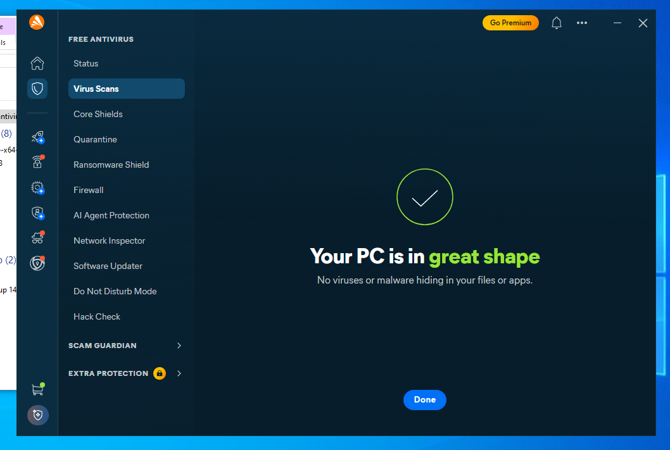

Screenshot 6: Anti-spyware full scan completed, showing summary of results.
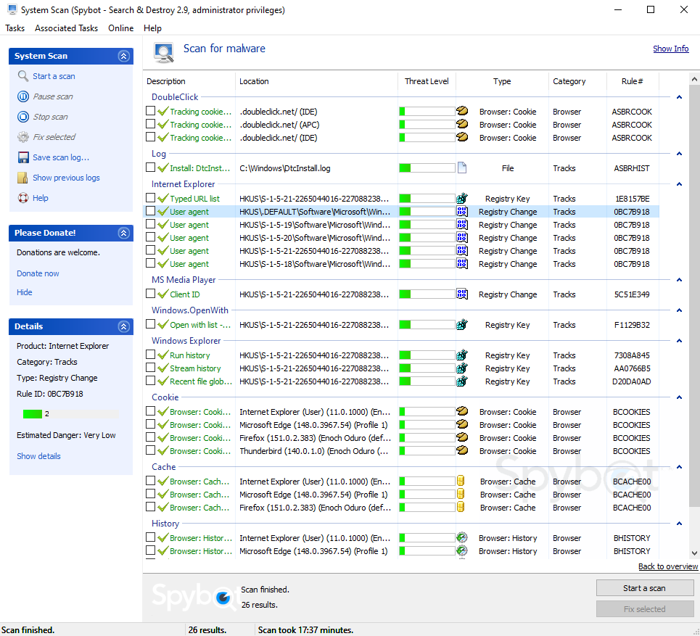
5.3 Importance of Keeping Software Updated
Antivirus and anti-spyware tools depend on two things staying current: the signature/definition database that identifies known malware, and the underlying detection engine including its heuristic and behavioural analysis components. New malware variants appear every day, so a database even a few days old can miss active threats. Most modern tools update automatically in the background, but it is worth explicitly confirming this is working rather than assuming it. A failed or paused update can leave a machine silently unprotected while still showing a green icon on screen. Additionally, the application itself, not just its definitions, needs periodic version updates to patch vulnerabilities in the security software itself and to keep pace with evolving threat techniques.

5.4 Proposed Scan and Update Schedule

Activity | Frequency | Notes
Definition/database updates | Automatic, continuous (checked hourly) | Leave auto-update enabled; verify weekly it is actually current
Real-time protection | Always on | Should never be disabled except during controlled troubleshooting
Quick scan | Daily | Low system impact; catches threats in common locations
Full system scan | Weekly | Schedule overnight or off-hours to avoid disrupting work
Anti-spyware full scan | Weekly or bi-weekly | Can run on the same day as the antivirus full scan
Software/engine version check | Monthly | Confirm the application itself, not just definitions, is current

5.5 Evaluating Effectiveness in a Real-World Scenario
A meaningful evaluation of security software looks at more than just whether it found anything during a scan. The following factors should be considered:
- Detection rate against both known and emerging (zero-day) threats. Independent testing labs such as AV-Comparatives and AV-TEST provide more reliable benchmarks than vendor marketing figures.
- False-positive rate. Software that repeatedly flags legitimate files erodes user trust over time and encourages people to dismiss or disable warnings.
- System performance impact. Heavy resource usage during scans and real-time
monitoring is particularly noticeable on lower-specification hardware and can lead
users to disable protection.
- Integration with the operating system's built-in protections. Running two real-time antivirus engines simultaneously is generally not recommended, as they can conflict and cause both performance and detection issues.
- Vendor response time. How quickly the vendor pushes definition updates in response to newly discovered threats is a strong indicator of ongoing reliability.

In practice, a layered approach is more effective than relying on any single tool. This means keeping the operating system and all applications patched, maintaining one well-configured antivirus engine with real-time protection enabled, running periodic dedicated anti-spyware scans, and pairing all of this with user awareness training as covered in Task 4. No software alone is sufficient without the human element.

End of Report

